

Vellore Institute of Technology, Vellore

Course Name: Data Structures & Algorithms Course Code: PMCA501P
Student Name
Submission Date:
Instructor’s Name- Dr. Vijayan E

CycleSheet 2
- Linear search for Sorted Array #include<stdio.h>

int linearSearchSorted(int arr[], int n, int data) { for (int i = 0; i < n; i++) {
if (arr[i] == data) {
printf("Element found at location %d\n", i + 1); return i;
} else if (arr[i] > data) {

break;
}
}

return -1;
}

void main() { int n, data;
printf("Enter the number of elements (sorted array): \n"); scanf("%d", &n);
int arr[n];

printf("Enter sorted array elements: \n"); for (int i = 0; i < n; i++) {
scanf("%d", &arr[i]);

}

printf("Elements are: "); for (int i = 0; i < n; i++) { printf("%d ", arr[i]);
}

printf("\nEnter data to search: "); scanf("%d", &data);

// Call linear search for sorted array
int result = linearSearchSorted(arr, n, data);

if(result == -1) {
printf("Element not found\n");

}
}

Output-

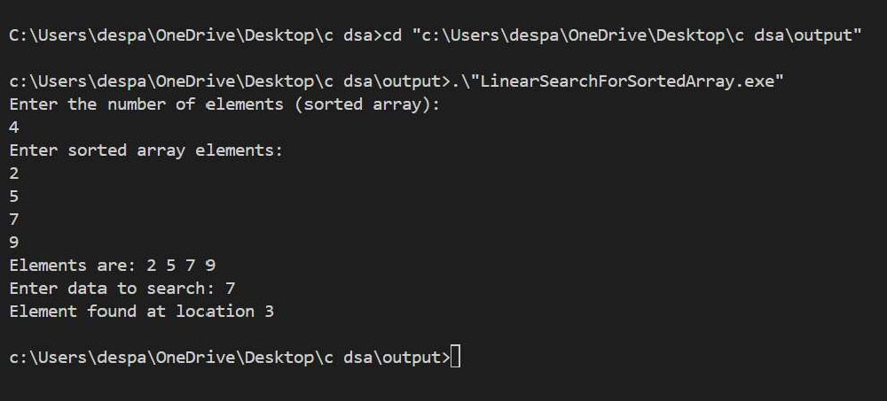

- Linear search for unsorted Array #include<stdio.h>
int linearSearch(int arr[],int n, int data){ int found=0;
for (int i = 0; i < n; i++)
{

if(arr[i]==data){
printf("Element found at location %d ",i+1); found=1;
break;

}
}

if(found ==0)
return -1;
}

void main(){ int n,data;
printf("Enter the number of elements: \n"); scanf("%d",&n);

int arr[n];
printf("Enter array elements: \n"); for (int i = 0; i < n; i++)
{

scanf("%d",&arr[i]);
}

printf("Elements are: "); for (int i = 0; i < n; i++)
{

printf("%d ",arr[i]);
}

printf("Enter data to search: "); scanf("%d",&data); linearSearch(arr,n,data);
}

Output-
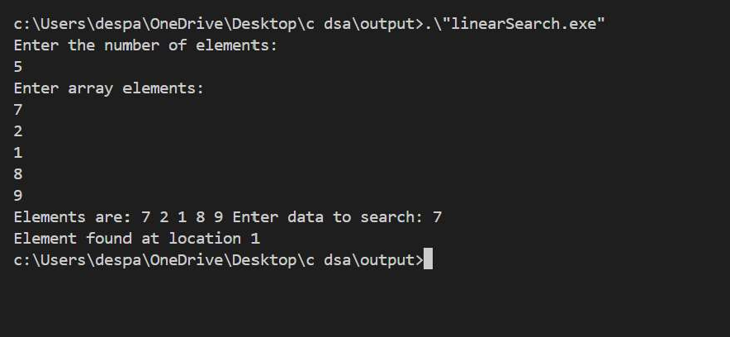

- Binary Search

int binarySearch(int arr[],int n ,int data){ int low=0, high=n-1; while(low<=high){
int mid=(low+high)/2; if(data==arr[mid]){ return mid+1;
}
else if (data<arr[mid])
{

high=mid-1;
}

else{
low=mid+1;

}
}

return -1;
}

int main(){ int n,data;
printf("Enter the number of elements: \n"); scanf("%d",&n);
int arr[n];
printf("Enter array elements: \n"); for (int i = 0; i < n; i++)
{

scanf("%d",&arr[i]);
}

printf("Elements are: "); for (int i = 0; i < n; i++)
{

printf("%d ",arr[i]);
}

printf("Enter data to search: "); scanf("%d",&data);
int loc=binarySearch(arr,n,data); if(loc==-1){
printf("Element not found ");

}
else
printf("Element found at index %d",binarySearch(arr,n,data));
}

Output-

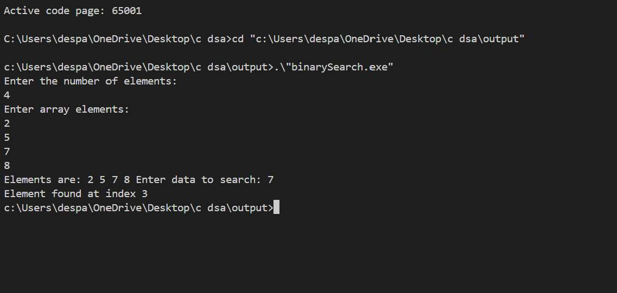
- Insertion Sort #include<stdio.h>

// Insertion Sort
void insertionSort(int arr[], int n) { for (int i = 1; i < n; i++) {
int temp = arr[i]; int j = i - 1;
while (j >= 0 && arr[j] > temp) { arr[j+1] = arr[j];
j--;

}
arr[j+1] = temp;
}
}

int main() { int n;
printf("Enter number of elements: "); scanf("%d", &n);
int arr[n];
printf("Enter elements: "); for (int i = 0; i < n; i++) {
scanf("%d", &arr[i]);

}

insertionSort(arr, n);

printf("After Sorting: "); for (int i = 0; i < n; i++) { printf("%d ", arr[i]);

}
return 0;
}

Output-
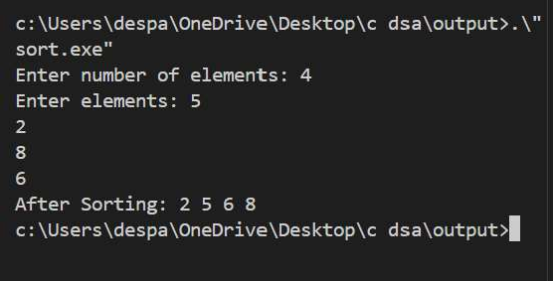
- Merge Sort #include<stdio.h>

// Merge function
void merge(int arr[], int lb, int mid, int ub, int n) { int brr[n];
int i = lb, j = mid + 1, k = lb;

while (i <= mid && j <= ub) { if (arr[i] <= arr[j]) {
brr[k++] = arr[i++];
} else {
brr[k++] = arr[j++];

}
}

while (i <= mid) brr[k++] = arr[i++]; while (j <= ub) brr[k++] = arr[j++];

for (int i = lb; i <= ub; i++) arr[i] = brr[i];
}

// Merge Sort function
void mergeSort(int arr[], int lb, int ub, int n) { if (lb < ub) {
int mid = (lb + ub) / 2; mergeSort(arr, lb, mid, n); mergeSort(arr, mid+1, ub, n); merge(arr, lb, mid, ub, n);
}
}

int main() { int n;
printf("Enter number of elements: "); scanf("%d", &n);
int arr[n];
printf("Enter elements: "); for (int i = 0; i < n; i++) {
scanf("%d", &arr[i]);

}

mergeSort(arr, 0, n-1, n);

printf("After Sorting: "); for (int i = 0; i < n; i++) { printf("%d ", arr[i]);
}

return 0;
}

Output-
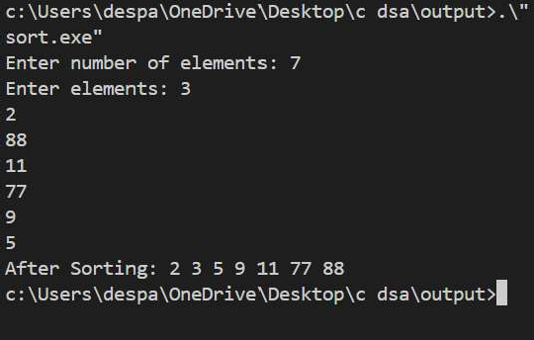

- Bucket Sort #include <stdio.h> #include <stdlib.h>

// Function to perform insertion sort on each bucket void insertionSort(int arr[], int n) {
for (int i = 1; i < n; i++) { int temp = arr[i];
int j = i - 1;
while (j >= 0 && arr[j] > temp) { arr[j + 1] = arr[j];
j--;

}
arr[j + 1] = temp;
}
}

// Bucket Sort function
void bucketSort(int arr[], int n) {
// Find the maximum value in the array to determine bucket range int max = arr[0];
for (int i = 1; i < n; i++) { if (arr[i] > max) {
max = arr[i];

}
}

// Create buckets (each bucket is a dynamic array)
int bucketCount = 10; // For simplicity, using 10 buckets int **buckets = (int **)malloc(bucketCount * sizeof(int *));
int *bucketSizes = (int *)malloc(bucketCount * sizeof(int)); // To keep track of bucket sizes

// Initialize buckets and sizes
for (int i = 0; i < bucketCount; i++) { buckets[i] = (int *)malloc(n * sizeof(int)); bucketSizes[i] = 0;
}

// Distribute elements into buckets for (int i = 0; i < n; i++) {
int bucketIndex = (arr[i] * bucketCount) / (max + 1); // Normalize the value to a bucket index
buckets[bucketIndex][bucketSizes[bucketIndex]++] = arr[i];

}

// Sort each bucket and concatenate the result

int index = 0;
for (int i = 0; i < bucketCount; i++) {
insertionSort(buckets[i], bucketSizes[i]); // Sort the bucket for (int j = 0; j < bucketSizes[i]; j++) {
arr[index++] = buckets[i][j]; // Concatenate sorted buckets into the original array

}
}

// Free allocated memory for buckets for (int i = 0; i < bucketCount; i++) {
free(buckets[i]);

}
free(buckets); free(bucketSizes);
}

// Main function to test bucket sort int main() {
int n;
printf("Enter number of elements: "); scanf("%d", &n);
int arr[n];
printf("Enter elements: "); for (int i = 0; i < n; i++) {
scanf("%d", &arr[i]);

}

printf("Before Sorting: "); for (int i = 0; i < n; i++) {

printf("%d ", arr[i]);
}

bucketSort(arr, n);

printf("\nAfter Sorting: "); for (int i = 0; i < n; i++) {
printf("%d ", arr[i]);

}

return 0;
}

Output-
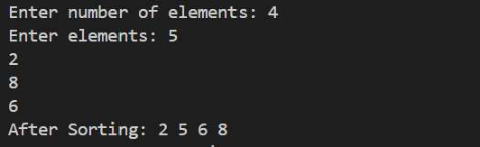

- Shell Sort #include<stdio.h>

// Shell Sort
void shellSort(int arr[], int n) {
for (int gap = n / 2; gap >= 1; gap /= 2) { for (int j = gap; j < n; j++) {
for (int i = j-gap; i >= 0; i -= gap) { if (arr[i+gap] > arr[i]) {
break;
} else {

int temp = arr[i+gap]; arr[i+gap] = arr[i];
arr[i] = temp;
}
}
}
}
}

int main() { int n;
printf("Enter number of elements: "); scanf("%d", &n);
int arr[n];
printf("Enter elements: "); for (int i = 0; i < n; i++) {
scanf("%d", &arr[i]);

}

shellSort(arr, n);

printf("After Sorting: "); for (int i = 0; i < n; i++) { printf("%d ", arr[i]);
}
return 0;
}

Output-

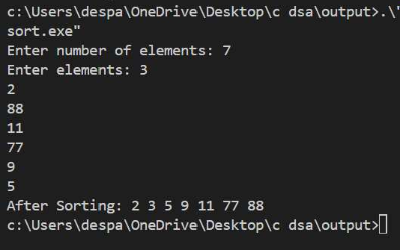

- Binary Search Tree #include <stdio.h> #include <stdlib.h>

struct node { int data;
struct node *left; struct node *right;
};
struct node *root;

void inorder(struct node *root) { if (root == NULL) {
return;

}
inorder(root->left); printf("%d ", root->data); inorder(root->right);
}

// Function to find the minimum value node in a subtree (used for in-order successor) struct node* findMin(struct node* parent) {
while (parent->left != NULL) { parent = parent->left;
}
return parent;
}

// Function to delete a node from the BST
struct node* deleteNode(struct node* parent, int d) { if (parent == NULL) {
return parent; // Base case: Node to be deleted is not found

}

// Traverse the tree to find the node to delete if (d < parent->data) {
parent->left = deleteNode(parent->left, d);
} else if (d > parent->data) {
parent->right = deleteNode(parent->right, d);
} else {
// Node to be deleted found (parent->data == d)

// Case 1: No child (Leaf node)
if (parent->left == NULL && parent->right == NULL) { free(parent);
return NULL;

}

// Case 2: One child
else if (parent->left == NULL) {
struct node* temp = parent->right; free(parent);
return temp;
} else if (parent->right == NULL) { struct node* temp = parent->left; free(parent);
return temp;

}

// Case 3: Two children else {
struct node* temp = findMin(parent->right); // Find in-order successor (minimum in right subtree)
parent->data = temp->data; // Replace data with in-order successor's data
parent->right = deleteNode(parent->right, temp->data); // Delete the in-order successor
}

}
return parent;
}

struct node* add(struct node* parent, int d) { if (parent == NULL) {
parent = (struct node*)malloc(sizeof(struct node)); parent->data = d;
parent->left = NULL; parent->right = NULL;
} else if (d < parent->data) {

parent->left = add(parent->left, d);
} else {

parent->right = add(parent->right, d);
}

return parent;
}

int main() { int n, d;
root = NULL;

printf("Enter number of elements you want to insert: \n"); scanf("%d", &n);

for (int i = 0; i < n; i++) {
printf("Enter data to be inserted: "); scanf("%d", &d);
root = add(root, d);

}

printf("Inorder traversal before deletion:\n"); inorder(root);
printf("\n");

printf("Enter the element to delete: "); scanf("%d", &d);
root = deleteNode(root, d);

printf("Inorder traversal after deletion:\n");

inorder(root); printf("\n");

return 0;
}

Output-
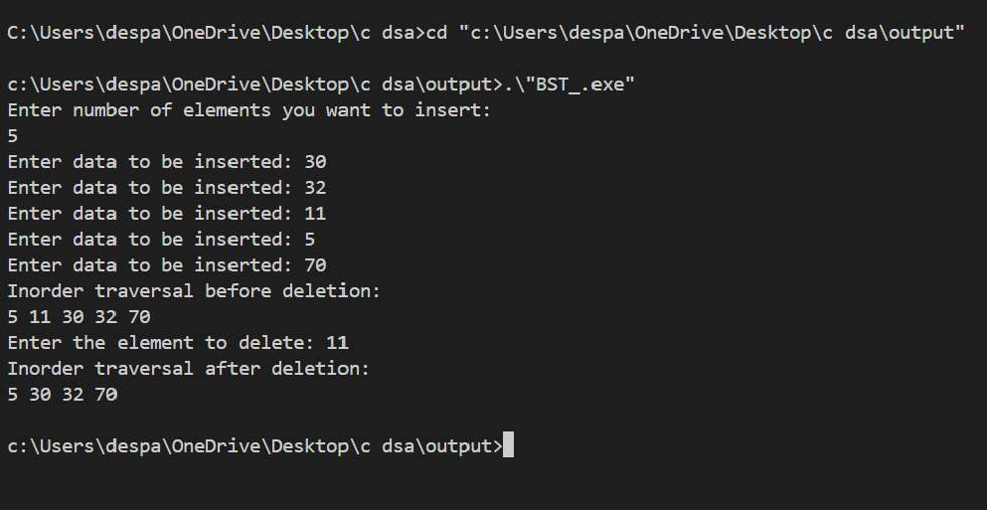

- Binary Search Tree traversals #include <stdio.h>
#include <stdlib.h>

// Define the structure for a tree node struct Node {
int data;
struct Node *left; struct Node *right;
};

// Function to create a new tree node struct Node* createNode(int data) {
struct Node* newNode = (struct Node*)malloc(sizeof(struct Node)); newNode->data = data;
newNode->left = newNode->right = NULL; return newNode;
}

// Function to insert a new node into the BST struct Node* insert(struct Node* node, int data) {
if (node == NULL) {
return createNode(data);

}
if (data < node->data) {
node->left = insert(node->left, data);
} else {
node->right = insert(node->right, data);

}
return node;
}

// Pre-order Traversal (Root, Left, Right) void preOrderTraversal(struct Node* root) {
if (root != NULL) {
printf("%d ", root->data); // Visit the root preOrderTraversal(root->left); // Traverse the left subtree preOrderTraversal(root->right); // Traverse the right subtree
}

}

// In-order Traversal (Left, Root, Right) void inOrderTraversal(struct Node* root) {
if (root != NULL) {
inOrderTraversal(root->left); // Traverse the left subtree printf("%d ", root->data); // Visit the root inOrderTraversal(root->right); // Traverse the right subtree
}
}

// Post-order Traversal (Left, Right, Root) void postOrderTraversal(struct Node* root) {
if (root != NULL) {
postOrderTraversal(root->left); // Traverse the left subtree postOrderTraversal(root->right); // Traverse the right subtree printf("%d ", root->data); // Visit the root
}
}

// Main function to test the BST and traversals int main() {
struct Node* root = NULL;

// Insert elements into the BST root = insert(root, 10); insert(root, 5);
insert(root, 20);
insert(root, 3);

insert(root, 7);
insert(root, 15);
insert(root, 30);

// Traversals
printf("Pre-order Traversal: "); preOrderTraversal(root); printf("\n");

printf("In-order Traversal: "); inOrderTraversal(root); printf("\n");

printf("Post-order Traversal: "); postOrderTraversal(root); printf("\n");

return 0;
}

Output-
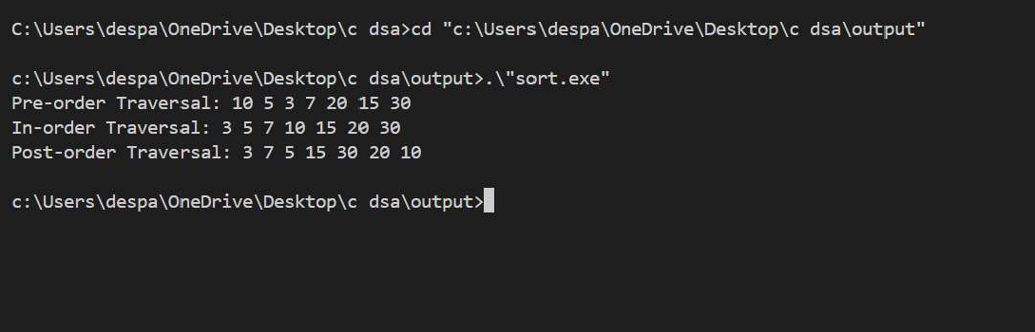
- Binary Sort #include <stdio.h>

// Function to perform binary search
int binarySearch(int arr[], int item, int low, int high) { if (high <= low)
return (item > arr[low]) ? (low + 1) : low;

int mid = (low + high) / 2;

if (item == arr[mid]) return mid + 1;

if (item > arr[mid])
return binarySearch(arr, item, mid + 1, high); return binarySearch(arr, item, low, mid - 1);
}

// Function to sort array using Binary Insertion Sort void binaryInsertionSort(int arr[], int n) {
int i, j, selected, location;

for (i = 1; i < n; ++i) { selected = arr[i];

// Find location where selected element should be inserted location = binarySearch(arr, selected, 0, i - 1);

// Move all elements after location to create space for (j = i - 1; j >= location; --j)
arr[j + 1] = arr[j];

arr[location] = selected;
}

}

// Main function to test the Binary Insertion Sort int main() {
int n;
printf("Enter number of elements: "); scanf("%d", &n);
int arr[n];
printf("Enter elements: "); for (int i = 0; i < n; i++) {
scanf("%d", &arr[i]);

}

printf("Before Sorting: "); for (int i = 0; i < n; i++) {
printf("%d ", arr[i]);

}

binaryInsertionSort(arr, n);

printf("\nAfter Sorting: "); for (int i = 0; i < n; i++) {
printf("%d ", arr[i]);

}

return 0;
}

Output-

